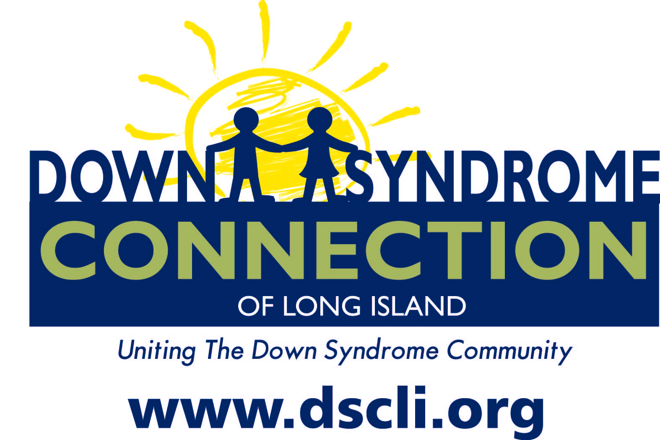

The Down Syndrome Connection of Long Island

Invites all

Parents of children with Down syndrome and Professionals

to attend an interactive workshop at
Good Samaritan’s Center for Pediatric Specialty Care



Presenter– Randy Young
Education Outreach Specialist LIPC and Administrator for TRIAD

Monday, November 4th, 2013
7:30 PM – 9:00 PM

655 Deer Park Avenue
Babylon

This workshop explores what “AT” assistive technology is and provides an overview of the role that AT plays in a student’s “IEP” Individualized Educational Plan. We will examine what questions should be considered in the assessment process. Resources will be provided to assist participants in furthering their understanding of AT. This interactive workshop will demo the iPad as one example of an accessible AT device that can improve outcomes for students.
Meet other parents as well and find out about local resources and events that are available to you and your child here on Long Island.
Please RSVP at www.dscli.org or call Shana at (631) 678-6810

